The Free Energy Landscape Method Overestimates Transition Rate Constants in a Kinetic Ising Model

Is the Free Energy Landscape Informative About Transition Rates? Lessons from the Kinetic Ising Model

Daniel Sigg,^{1,a)} Vincent Voelz,² and Vincenzo Carnevale ^{3,b)}

¹dPET, Spokane, WA 99223, USA
²Department of Chemistry, Temple University, Philadelphia, Pennsylvania 19122, USA
³Institute for Computational Molecular Science, College of Science and Technology, Temple University, Philadelphia, Pennsylvania 19122, USA
Diffusion across a free energy landscape or potential of mean force is a widely used approach to modeling kinetics of complex molecular systems such as proteins, for which coarse-graining is necessary to reduce the state space to a manageable size for computing relaxation rates. Here we compare native barrier transition rates from a kinetic Ising model with those calculated from a coarse-grained master equation whose rate constants are averaged over the microcanonical ensemble, and reformulated for other ensembles in one and two dimensions. The calculated rates are roughly 50% larger than the native rates for varying environment conditions. We provide an explanation for the systematic impediment to configurational progress in terms of microscopic degrees of freedom. Our simple model illustrates that, even with the detailed description of microstates provided by the microcanonical approach, true rate constants are overestimated. This suggests that the reaction coordinates that optimally describe equilibrium properties and response to perturbations of a system might not be the most appropriate to model its kinetics.

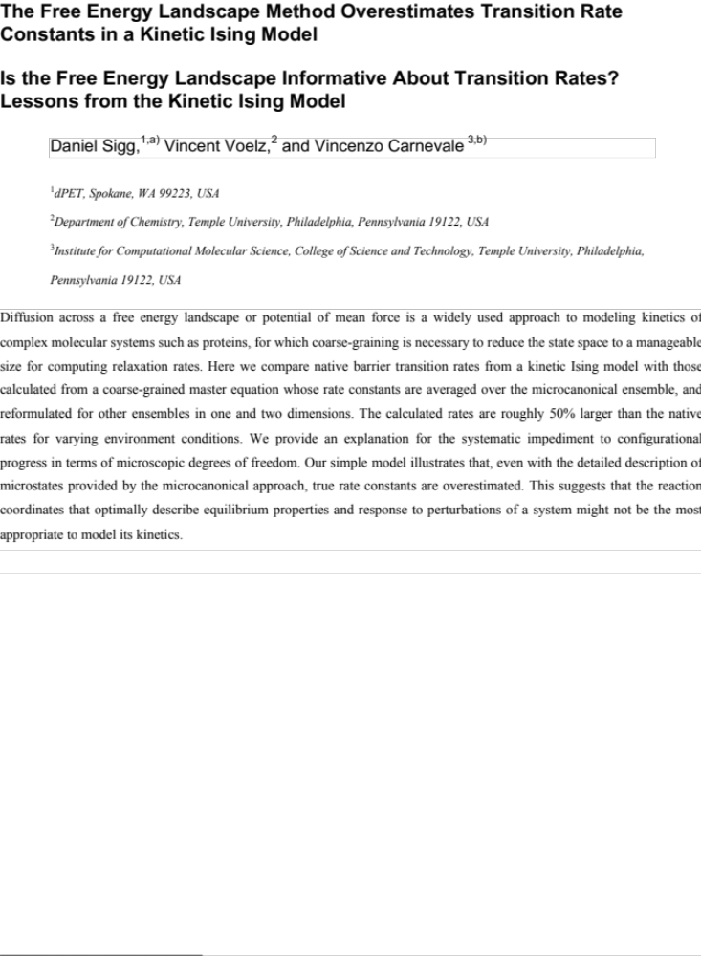

_____________________________
- Electronic mail: dansigg@gmail.com
^{b)} Electronic mail: vincenzo.carnevale@temple.edu

I. INTRODUCTION
The kinetics of small systems are dominated by fluctuations. This is evident in single molecule recordings of proteins and other biological macromolecules. A good example of protein fluctuations is gating transitions between conductance states in an ion channel (Fig. 1). Channel gating is temperature-dependent and is also sensitive to other environmental variables such as voltage or ligand concentration (ref). Molecular dynamics simulations are very effective at sampling fluctuations and exploring the effect of the most diverse environmental perturbations. Thus they are seemingly the most appropriate tool to study complex phenomena like channel gating. However, in its most basic form, this computational approach is limited to the exploration of a trajectory spanning only relatively short time-scales.
Since their inception, molecular dynamics simulations have benefited from importance sampling approaches that estimate properties of the canonical distribution function of a given of molecular systems by drawing samples from conveniently chosen auxiliary distributions (I need to add citations). In practice, these techniques are used to speed up the exploration of the configurational space: if all the relevant configurations are made equally probable by introducing appropriate biasing terms in the Hamiltonian, then relatively short trajectories provide reliable estimates for the various expected values and thus predictive power over thermodynamic observables (many references here including Harpole and Delemotte, 2017). Besides the technical aspects related to the design of unbiased estimators that use these auxiliary trajectories to infer parameters of the canonical distribution, the art of “enhanced sampling” lies in choosing appropriately the set of “relevant configurations”: which ones should be considered to optimally describe the equilibrium properties of a system?
A widely adopted approach to characterize a molecular system is to focus on its response to small perturbations. This is the case, for instance, of voltage gated ion channels gating: a sudden change in transmembrane potential is generated to monitor relaxation toward a stationary state. In cases like this one, in which a well-defined generalized force (in this case the potential, V) is applied to the system to drive a transition, the distribution associated to the conjugate displacement (in this case the gating charge, q) in absence of the field provides information about the static response of the system. For instance, the fluctuation of q at equilibrium gives the susceptibility of the system (in linear regime) to the applied potential V. Thus, in these cases, sampling uniformly configurations differing by the value of the displacement conjugate to the external force is crucial for characterizing reliably the energetics of the system. In other words, there is a natural choice for the reaction coordinate, x, parametrizing a free energy landscape, F(x).
In this paper we address the related question of kinetics: Is the coarse-graining used to describe the system’s equilibrium optimal to analyze the system’s dynamics as well? In other words: Does Brownian diffusion on F(x) provide a good phenomenological model of the system’s kinetics? The appeal of this approach is clear: the diffusion coefficient (D) to be used in the associated Langevin equation can be obtained from the same simulation yielding F(x) (Best and Hummer, 2010; Straub et al., 1987; others) and therefore a single simulation setup could be used to enhance the sampling, characterize equilibrium and analyze kinetics.
Here we evaluate the accuracy of this approach using a simple lattice model with known thermodynamic properties. Coarse-grained rate constants averaged over the microcanonical ensemble were used to construct a master equation, from which macroscopic transition rates were calculated. The macroscopic rate constants were compared to native transition rates obtained from unbiased Monte Carlo simulations, and were found to be about 50% larger. The source of the discrepancy is conjectured to be a mild form of “frustration” that prevents subsets of microscopic transitions from occurring, thereby lengthening native trajectory pathways.
II. THEORY
- Electrical Ising model
We chose as our system an electrical variant of the traditional Ising model. The model is comprised of a two-dimensional lattice of N locally interacting particles that responds to an applied voltage V rather than a magnetic field H in the traditional model. The internal energy E of the electrical Ising model is:
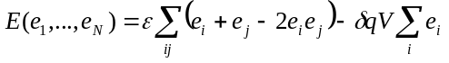, (1)
where the index j denotes nearest-neighbors to the i^{th} particle. Particle states are e_{i} = 0 (resting) and 1 (active). Every activating particle moves a small “gating” charge δq, modeled after gating currents in voltage-gated ion channels, proteins that undergo large-scale fluctuations for the purpose of cellular signaling. The internal energy of the Ising model increases in increments of 2ε from a minimum of 0 (uniform grid) to a maximum of 2Nε (checkerboard pattern), where ε is the inter-particle energy. The order parameter q is the total charge displacement:
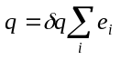, (2)
whose value ranges from 0 to Nδq. The electric and magnetic Ising models are isomorphic. One model can be converted to the other with: s_{i} ↔ 2e_{i} – 1, ε ↔ 2J, δq ↔ 2μ, and V ↔ H, where the magnetic variables are: particle states s_{i} = ±1, coupling energy J, magnetic moment μ, and field H.
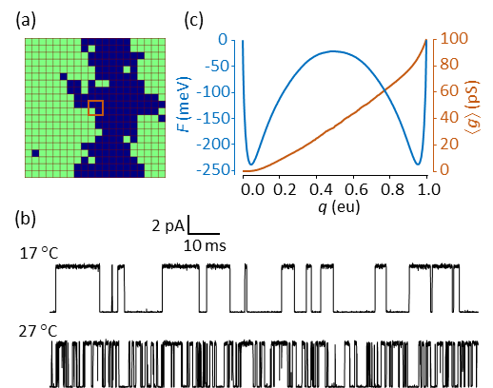
FIG. 1. (a) 20 x 20 Ising model. Green cells indicate activated particles. The central brown square is a 2 x 2 “pore”, where the instantaneous conductance g (not to be confused with density of states) is proportional to the number of activated particles within pore boundaries. (b) Native Monte Carlo simulation of the single channel current i = g(V – V_{rev}) at two temperatures. V = 0 mV; V_{rev} = –60 mV. The current was filtered with a cutoff frequency of 1.0 kHz. No additional noise was added. (c) 1D free energy landscape F(q) and mean conductance ⟨g(q)⟩ obtained from time averaging over a 0.4 s simulation at 17 °C.
Simulated trajectories of the electrical Ising model are qualitatively similar to laboratory-generated traces from voltage-gated ion channels (Fig. 1b). Both demonstrate stochastic switching between macrostates. We made no attempt at a realistic depiction of channel gating; instead, the aim was to test whether slow barrier kinetics were preserved after coarse-graining to a Brownian motion landscape. There are practical advantages to using the Ising model rather than performing detailed molecular dynamics simulations of a protein such as an ion channel: (1) There is no inertial memory in Ising dynamics, obviating the need for a time-dependent diffusion coefficient; (2) Particle interactions are nearest-neighbor and regular, allowing rapid calculation of kinetics and long-term trajectories; (3) The Ising system is bounded in E and N, and its thermodynamics can be fully described using the microcanonical ensemble; (4) Microscopic rates can be averaged over the microcanonical ensemble; (5) Coarse-grained kinetics are expressible in the form of a master equation that can be solved numerically.
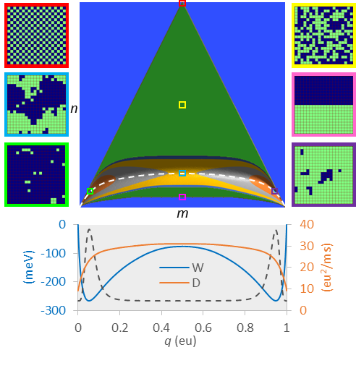
FIG. 2. Course graining the 20 x 20 electrical Ising model (N = 400). The green triangle is the set of all accessible (m, n) states (= 73,448). The 2D contour region at the base of the triangle is the reaction pathway comprised of a reduced number of states (= 22,149) constrained by F < F_{max}, under conditions: T = 22 °C; V = 0 mV; and F_{max} = 150 meV. The reaction pathway has maximum vertical span (bandwidth) of 68 cells at the separatrix. On either side, representative microscopic configurations are shown for: maximum energy (red); maximum entropy (yellow); saddle point region (blue); minimum transition state energy (pink); minimum free energy in state 1 (green) and in state 2 (purple). The dashed white line is the mean energy ⟨E(q)⟩. The projected 1D landscapes F(q) and D(q) are plotted at the bottom, with the equilibrium probability distribution P(q) superimposed (dotted line).
The coarse-graining procedure is illustrated in Fig. 2. Representative examples of the 2^{N} microscopic configurations are shown for a 20 x 20 Ising model (N = 400). Theoretically, microscopic dynamics are governed by a master equation, albeit a difficult one to solve due to the vast number of microstates. We binned the microstates onto a more manageable N x N grid containing the microcanonical density of states g(E, q) (Pleimling and Behringer, 2005). Each mesoscopic state (E, q) is uniquely specified by an integer pair (m, n), where q = mδq and E = 2nε. The state space of the Ising model with periodic boundaries is an equilateral triangle with a concavity in the base. The height of the raised base is 2N^{½}ε, giving rise to the well-known symmetry-breaking properties of the 2D Ising model. The purpose of coarse-graining was to construct a mesoscopic master equation whose smallest non-zero eigenvalue is the macroscopic relaxation rate.
Since realistic simulations are run at constant temperature and voltage, a free energy landscape F(T, V) on the (m, n) grid was constructed from g(E, q) = g_{mn} (integer notation):
. (3)
F_{nm} is a potential of mean force (pmf) with respect to the discrete variables m and n, but for large enough N, it is effectively a smooth function of q and E. For positive values of ε, only a lower portion of the triangle is appreciably populated (paramagnetism in the traditional Ising model). Since we were interested in the coarse-grained master equation between (m, n) states, we limited the number of mesoscopic states by establishing a cut-off value F_{max} chosen to be at least 6 kT greater than the saddle point energy between the two ordered states.
A second level of coarse-graining involved projecting the 2D landscape F_{nm}(T, V) onto a 1D pmf F_{m}(T, V) shown at the bottom of Fig. 2. The free energy projection is defined by:
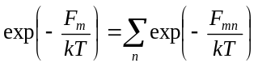. (4)
The 1D pmf has N + 1 states. The 1D and 2D pmfs provide exact thermodynamic information, though the 1D landscape is limited to q. From the 2D landscape we can, using Boltzmann averaging, obtain heat capacities for different ensembles (Fig. 3); these are less peaked than the infinite-particle Onsager solution around the critical temperature, in addition to being right-shifted. Both 1D and 2D pmfs yield the mean charge displacement ⟨q(V)⟩, which is steeper at lower temperatures.

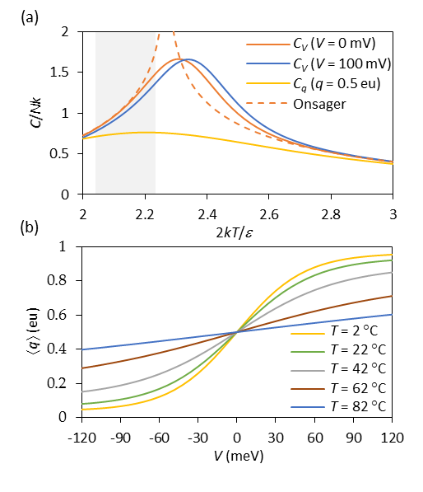
FIG. 3. (a) Heat capacities C of the 20 x 20 Ising model for constant V and q, as a function of normalized temperature. The dotted curve is the exact Onsager solution for an infinite system (Toda et al., 1992). The shaded region indicates the physiological range of T from 10 °C to 40 °C. (b) Mean charge displacement ⟨q⟩ versus V for different temperatures.
- Microscopic rates
In order to study dynamics we needed a model for microscopic rates. These are constrained by detailed balance:
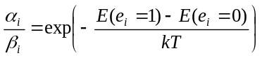, (5)
where α_{i} and β_{i} are the forward and backward rates associated with the activation of the i^{th} particle. We assumed barrier kinetics of the form:
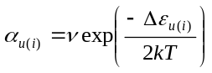, (6a)
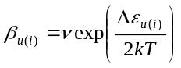 , (6b)
where ν is the pre-exponential factor and the energy of activation Δε depends on the number u(i) of neighboring activated particles, as follows:
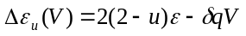 . (7)
There is nothing unique about our choice of rate constants. A different choice attributed to Glauber (Glauber, 1963) could be used if one wished to prevent the microscopic rate from exceeding ν.
Mesoscopic rates
There are only ten possible microscopic rate constants arising from combinations of u (0…4) and e (0, 1). The limited number of microscopic rates α and β manifest themselves as ten cardinal directions (five forward and five backward) available to an (m, n) state (Fig. 4). These mesoscopic rates have the form a_{kk′} = ⟨r_{kk′}⟩α_{u} and b_{k′k} = ⟨r_{k′k}⟩β_{u}, where ⟨r_{kk′}⟩ is a statistical factor representing transition frequencies from states k = (m, n) to k′ = (m′, n′). Detailed balance in the microcanonical ensemble is described by ⟨r⟩_{kk′} g_{k} = ⟨r⟩_{k′k} g_{k′}. The averaging of microscopic rates on a mesoscopic scale is the critical step in successfully coarse-graining the system kinetics. Except for the simplest possible Ising scheme (N = 4), the mesoscopic rate constants a_{kk′} and b_{k′k} are Boltzmann-weighted averages over many microstates. Not every cardinal direction is accessible to a particular microstate, even if other microstates within the same k = (m, n) state can undergo the move. We’ll revisit this point in the Discussion section.
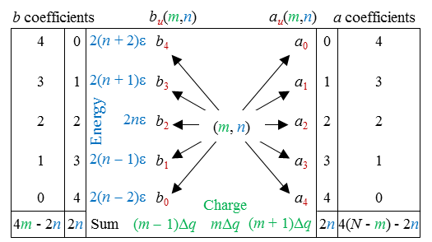
FIG. 4. Cardinal transitions from an (m, n) state. Constraints among the cardinal rates are expressed in the outer columns, where rate constants multiplied by the indicated coefficients sum to the four expressions on the bottom row. Detailed balance accounts for five additional relationships between opposing rates, expressed as: a_{u}/b_{u} = exp(−Δε_{u}/kT).
Projection of the 2D rate constants onto the m axis through Boltzmann averaging yielded the 1D rates a_{m} and b_{m}, or as continuous variables, a(q) and b(q). In 1D, detailed balance assumes the form: a(q)exp(−F(q)/kT) = b(q + δq)exp(−F(q + δq)/kT). The 1D diffusion coefficient D(q) was obtained from the Brownian motion expression 2D(q) = [a(q) + b(q)]δq². The 1D dynamics can be expressed either through a(q) and b(q), from which a master equation can be constructed, or through the landscape variables F(q) and D(q), which can be inserted into a Langevin equation. The two representations are equivalent for large systems, but because the Langevin equation is an approximation of the master equation valid only for small δq, we used the original master equation for our calculations. That said, predictions from Langevin simulation were not very different for the sizes of models we considered (N ≥ 256).
Apart from coarse-graining using the microcanonical ensemble, an alternative method for determining the 1D landscape variables F(q) and D(q) (or equivalently, a(q) and b(q)) for a particular set of environmental constraints was through native kinetic simulation of the Ising model. This is significant since time averaging under conditions of constant temperature, pressure, and other environmental constraints, is the usual procedure for determining parameter values in a complex system like a protein. For the 1D Ising representation, we obtained F(q) to within a constant value C by evaluating −kTlnP(q) over a very long trajectory, where P(q) is the time-averaged probability of being in the state q. The value of C was fixed using the boundary condition F(0) = 0. In our simulations, 1D ensemble and time-averaged quantities superimposed neatly, confirming ergodicity. With some variables, such as the “pore” conductance shown in Fig. 1, ensemble averaging is not possible since conductance was defined with respect to specific microconfigurations and is not a function of q and E. With the time-averaging method, the diffusion constant D could be obtained for all values of q from mean values of the forward and backward rates using the earlier expression for Brownian motion, or by simulating the filtered capacity current i_{g} = dq/dt within a narrow window in q, and using Nyquist’s theorem: 4DB = ⟨i_{g}²⟩ (Sigg et al., 1999), where the recording bandwidth B is related to the Gaussian filter cut-off value through B = 1.064f_{c}. This last procedure is similar to that described by Hummer (Hummer, 2005). From a practical standpoint, the shape of D(q) is not very important as the macroscopic rate is essentially determined by the value of D at the barrier peak (Fig. 5). This is because in our system barriers were sufficiently large (≥ 6 kT) that basin states thermalized rapidly compared to the rate-limiting barrier outflow.
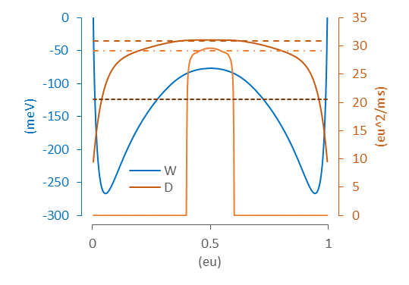
FIG. 5. Methods for calculating D. The dashed brown line represents the constant value of D (30.9 eu²/ms) that, when combined with the pmf W, generates the same forward rate as the spatial landscape D(q) (solid brown line). Simulations performed with a sharp umbrella window in the range q = 0.4 eu to 0.6 eu yielded a truncated landscape D(q) (solid orange line); Nyquist’s theorem applied to i_{g} fluctuations predicted D = 29.1 eu²/ms (dot-dashed orange line). For comparison, the effective value D consistent with the true kinetics of the native process is 20.5 eu²/ms (dark brown dotted line). Model parameters were: N = 400, T = 22 °C, V = 0 mV (reference model). Filter cut-off frequency for capacity current simulations: f_{c} = 5 x 10⁵ kHz.
- Macroscopic rates
The final level of coarse-graining involved barrier transitions between the two macroscopic states. Starting with the 1D and 2D free energy landscapes, we computed macroscopic rate constants k₁₂ and k₂₁ using three methods. In the first (eigenvalue) method, mesoscopic rate constants a, b were tabulated in a rate matrix Q constructed to satisfy the master equation dp/dt = pQ, where p(t) is the row vector of state probabilities (Sigg et al., 1999). The first non-zero eigenvalue of Q equals the sum k₁₂ + k₂₁. When necessary (V ≠ 0), the ratio k₁₂/k₂₁ was obtained using detailed balance so individual rates could be determined. Otherwise, for V = 0, symmetry requires k₁₂ = k₂₁. The second (mean first passage time) method involved truncating Q for q greater than the state 2 free energy minimum q₂, thus creating an invertible matrix Q′. The mean first passage time (MFPT) from q < q₂ to q₂ was obtained by solving Q′τ = u (Van Kampen, 1992), where τ is the column vector of MFPTs τ(q → q₂) and u is the unit vector. The quantity 1/τ(q₁→ q₂), where q₁ marks the location of the state 1 free energy minimum, is an accurate estimate of the forward rate constant k₁₂ for large enough barriers (≥ 6 kT) (Reimann et al., 1999). In the last (Monte Carlo) method, we constructed a coarse-grained master equation for the 2D mesoscopic rates on the (m, n) grid, and one for the projected 1D rates a(q) and b(q), from which long (4 s) Monte Carlo simulations generated exact first passage times between q₁ and q₂, the averages of which yielded k₁₂ and k₂₁.
- Native Monte Carlo simulation
A continuous-time Monte Carlo algorithm for simulating the electrical Ising system at constant T and V was used to obtain precise first passage times from q₁ to q₂. We obtained the inverse MFPT from thousands of recorded transitions and used this as the gold standard value for k₁₂ against which coarse-graining methods were judged. We could not verify the accuracy of the Monte Carlo method using independent methods, as we did for the 1D and 2D simulations. However, consistent outcomes were obtained using several “good” pseudorandom number generators (Fig. 6), suggesting the calculations were reliable.
III. NUMERICAL METHODS
The majority of Monte Carlo simulations and analysis routines were run on Temple University’s Compute server using customized software written in C. For each set of environmental conditions (N, T, V, F_{max}), six simulations ran simultaneously, comprising a single experiment. Each run generated the following: (1) the density of states g and transition frequencies ⟨r⟩; (2) 1D and 2D potentials of mean force and rate constants in the (N, T, V) ensemble; (3) simulated trajectories of the native process and coarse-grained master equation simulations in 1D and 2D; (4) mean first passage times for native, 1D, and 2D Monte Carlo simulations, and 1D and 2D master equations; and (5) eigenvalue analysis for 1D and 2D master equations. Output parameters for each experiment were expressed as the mean and standard error from the six independent runs. We chose as the reference model the 20 x 20 Ising grid (N = 400) with the following parameters: T = 22 °C; V = 0; ε = 24 meV; q_{max} = 1 eu; and ν = 5 x 10⁴ kHz. We ran additional experiments with different T, V, and N to determine their effect on rate constants. A total of 15 experiments were performed for this paper. The values of ε, δq = q_{max}/N, and ν were fixed for all experiments.
- Random number generators
We tested several pseudorandom number generators to address the possibility of biased sampling. These were: (1) Numerical Recipes© long-period L’Ecuyer generator with Bays-Durham shuffle (ran2) (Press et al., 1992); (2) Intel® MKL Library SIMD-oriented Fast Mersenne Twister (FMT) (Saito and Matsumoto, 2008); (3) Intel® MKL Library multiplicative congruential generator (MCG) (L’Ecuyer, 1999a); and (4) Intel® MKL Library combined multiple recursive generator (MRG) (L’Ecuyer, 1999b). Of the four generators, the MCG algorithm yielded outlying outcomes and greater variability (Fig. 6), and is not recommended for use in our model. Most simulations employed the ran2 algorithm. In a small number of cases involving large barriers where the performance of the random number generator was in doubt, repeating the simulations using the FMT and MRG algorithms helped confirm the outcome.
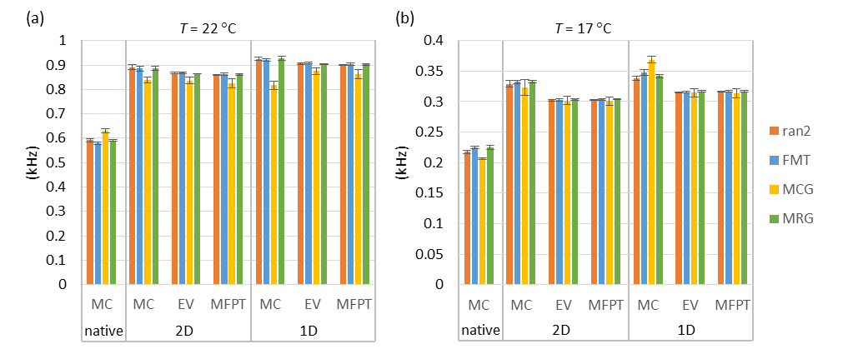
FIG. 6. Forward rate constant estimates (mean ± s.e., n = 6) from different methods (MC = Monte Carlo, EV = eigenvalue analysis, MFPT = mean first passage time) as a function of pseudorandom number generator. (a) Reference model. T = 22 °C. (b) Temperature lowered to 17 °C, which increased the barrier height and led to a discrepancy between Monte Carlo and the other two methods (EV and MFPT). Results were consistent between generators except in the case of the multiplicative congruential generator (MCG), which demonstrated lower accuracy and precision compared to the other three generators.
- Computing mesoscopic rates
The Metropolis Monte Carlo (MMC) method was used to compute average rates in the microcanonical distribution. Applying traditional MMC for infinite T and zero V allows every trial move to be accepted, in principle yielding the microcanonical ensemble. However, the large entropy gradient makes this algorithm impractical for all but the smallest systems, so a bias potential ω_{k} was applied to “flatten” the gradient and allow uniform sampling over all k = (m, n) mesostates. The 1/t variant of the Wang-Landau algorithm with endpoint F = 10⁻⁶ was used to rapidly obtain lnω_{k} (Belardinelli and Pereyra, 2007). MMC was implemented by picking a random particle to flip, and after determining the locations of the current state k and the trial state k′ on the (m, n) grid, applying the following acceptance criterion for the k → k′ transition:
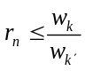, (8)
where r_{n} is a uniform random number from 0 to 1. At each discrete time s, the ten cardinal rates a_{u} and b_{u} were determined by summing microscopic rates over all particle transitions. For example, if 9 of N particles contribute to the backward transition (u, v) → (u – 1, v + 2), then the instantaneous rate b₄(s) would be assigned the value 9β₄, where β ₄ is the corresponding microscopic rate (Eq. 6b). The starting configuration for each simulation run was chosen randomly. Following an equilibration period of 2 x 10⁶ points, time-averaged forward rates were obtained over 2 x 10¹⁰ time points using the following formula:
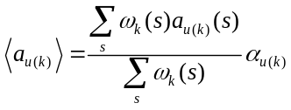, (9)
with a similar expression for reverse rates ⟨b_{u(k)}⟩. The ratio preceding a_{u(k)} in Eq. 9 is the mean transition frequency ⟨r_{kk′}⟩, which can be rewritten as ⟨r_{u(k)}⟩_{a}, or for the reverse transition, ⟨r_{u(k)}⟩_{b}. The microcanonical density of states was obtained from:
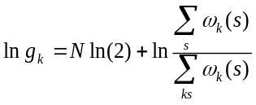. (10)
The density of states g_{k} and rate factors ⟨r_{u(k)}⟩_{a} and ⟨r_{u(k)}⟩_{b} were stored as N x N matrices lng, A_{u}, and B_{u} (Fig. 7). These eleven matrices are not independent (Fig. 4), but to avoid excessive sampling error, none were eliminated to reduce data storage. It should be emphasized that, like lng, A_{u} and B_{u} are statistical matrices that depend only on N. In order to calculate mesoscopic rate constants for any set of environmental conditions: T, V, and model parameters: ε, q_{max}, and ν, we applied: a_{u(k)} = ⟨r_{u(k)}⟩_{a}α_{u} and b_{u(k)} = ⟨r_{u(k)}⟩_{b}β_{u}, using Eqs. 6 and 7 for the microscopic rates α_{u} and β_{u}.
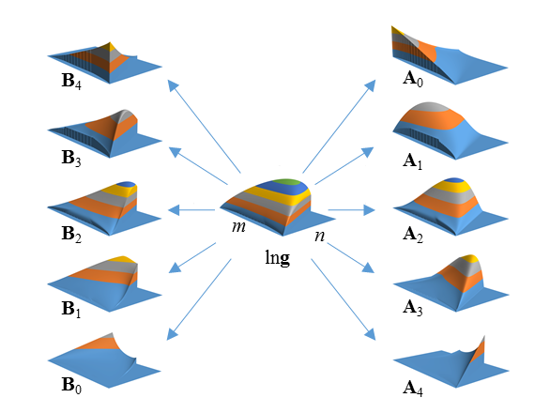
FIG. 7. Density of states (g) and cardinal rate (A, B) matrices for 20 x 20 Ising model. Vertical axes are not to scale. The n-axis was cut off at n = 254 due to limitations of the plotting software.
- Computing macroscopic rates
In order to compute macroscopic rates k₁₂ and k₂₁, a rate matrix Q was constructed. The upper diagonal terms of Q contained forward rates a_{u(k)} (2D) or a_{m} (1D), and lower diagonal terms contained backward rates b_{u(k)} (2D) or b_{m} (1D). Diagonal terms were assigned so that all row entries summed to zero, satisfying the master equation dp/dt = pQ. Macroscopic rate constants were then calculated from Q using the methods (Monte Carlo, eigenvalue, and MFPT) detailed in the Theory section.
A practical difficulty arose from the large size of Q, particularly in 2D cases. From N² possible mesoscopic states, somewhat less than half are accessible (Fig 2). For the 20 x 20 Ising model, the 2D size of Q would be 73,448 x 73,448. The number of accessible states l can be substantially reduced by establishing a free energy cutoff F_{max}. To avoid artificially constricting the barrier region, which would underestimate transition rates, F_{max} was chosen to be at least 150 mV higher than the saddle point energy. Further size reductions in Q were achieved by repacking it into band form. We numbered the mesostates in column order of increasing m and n(m), resulting in a maximum bandwidth d for the main diagonal equal to the width of the separatrix in the truncated free energy landscape. In banded form, the final size of Q was l x 2d+1. Typical values of l and d for the truncated 2D landscape were ~20,000 and ~70. By taking advantage of eigenvalue and linear routines designed for band matrices, macroscopic rates were calculated in short order. The eigenvalue and mean first passage time calculations were easily adapted for 1D calculations, where Q is tridiagonal (d = 1) and l = N + 1.
- Macroscopic rate constants from Monte Carlo simulation
A continuous-time Monte Carlo method (Sigg et al., 1999) was used to simulate the kinetics of both native and coarse-grained versions of the Ising model. The method avoids the shortcomings of the Metropolis algorithm, which is not designed for kinetics and uses a fixed time increment. In the case of the native process, at each step the state-dependent flip rate (α_{i} or β_{i}) for each particle i was determined, and particle rates were summed in the forward (∑α_{i}) and backward (∑β_{i}) directions. The combined transition rate was r = ∑α_{i} + ∑β_{i}. The time between transitions was randomly obtained from −lnr_{n}/r, and the particle to be flipped was chosen using a separate random draw, where individual probabilities of flipping were proportional to flip rate. After incrementing the time and flipping the chosen particle, the process was repeated until 4 seconds of simulation time was completed. The same algorithm could be used to simulate the coarse-grained master equation defined by Q.
IV. RESULTS
- Rate constants from Monte Carlo Simulation
First passage times from ~10⁴ transition events simulated in the native Ising model enabled us to compute macroscopic rate constants k₁₂ and k₂₁ with good precision. We consider from this point on only the forward rate k₁₂ since for a symmetrical free energy landscape (V = 0), used in all but two experiments, the two rates are equal. The value of k₁₂ was calculated as the inverse of the mean dwell time in the first ordered state (τ₁). We equated individual dwell times with the first passage time from q₁ to q₂, so that τ₁ = mfpt. The two-state approximation predicts an exponential distribution of dwell times between states. Figure 8 shows the count distributions from native, 1D, and 2D Monte Carlo simulations. A Sigworth-Sine transformation was applied to the dwell time data in order to generate uniform residuals while fitting (Sigworth and Sine, 1987). A helpful feature of the Sigworth-Sine transformation is that it causes the distribution to peak at τ₁.
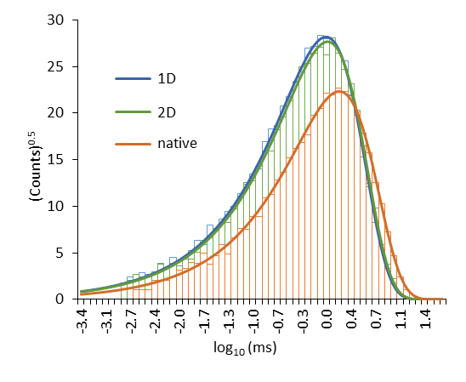
FIG. 8. Sigworth-Sine plot of forward passage times.
It is apparent from Fig. 8 that for both the native process and the two levels of coarse-graining, the binned dwell times faithfully followed the theoretical distribution across four orders of magnitude. Even with expected binning error, fits of the Sigworth-Sine plot using the adjustable value τ_{fit} yielded results very close to the averaged τ₁ (Table I). The two-state approximation for small (N ~ 400) kinetic Ising systems is evidently a good one.

TABLE I. Forward Mean First Passage Times from Monte Carlo simulation.
 | Native | 2D | 1D
counts | 6,776 | 10,397 | 10,791
τ₁ (ms) | 1.672 ± 0.020ª | 1.145 ± 0.011ª | 1.086 ± 0.010ª
k₁₂ (kHz) | 0.5982 ± 0.0073^{b} | 0.8735 ± 0.0085^{b} | 0.9210 ± 0.0088^{b}
τ_{fit} (ms) | 1.675 | 1.146 | 1.088
ªstandard error (τ₁) = τ₁/counts^{½} (property of exponential distribution).
^{b}standard error (k₁₂) = (k₁₂/τ₁)s.e.(τ₁).
The coarse-grained representations (1D and 2D) predicted significantly smaller values of τ₁ than the native process, and therefore a larger k₁₂. The 2D landscape yielded a marginally more accurate result than the 1D landscape. These are the major findings of our study.
- Comparing numerical methods
In the coarse-grained systems, we checked the Monte Carlo estimate for k₁₂ against the eigenvalue and MFPT methods. There was generally excellent agreement between the three calculations for both 1D and 2D cases, confirming that coarse-graining overestimates macroscopic rate constants compared to the native process. There were some mild discrepancies. (Fig 6b). In two cases where the PMF barrier was quite large (T = 17 °C and N = 484), the Monte Carlo estimates were slightly larger than the other two methods, independent of which “good” pseudorandom number generator was used. An instance where numerical algorithms failed completely was in the calculation of eigenvalues for the case V = 100 mV, which generated a non-zero value for the zeroth eigenvalue. This obviously incorrect result was not included in our final analysis, but we did include the mildly discrepant values ascribed to random number bias as part of the average over all methods.
- Rate constants as a function of N, T, and V
The dependence of k₁₂ on structural and environmental variables N, T, and V can be predicted from the shapes of 1D energy and diffusion landscapes shown in Fig. 9. Reactive rate theory predicts that k₁₂ should decrease exponentially with forward barrier height ΔF and increases linearly with maximum D, with a minor role played by the relative curvatures around state 1 and the barrier (Sigg, 2014). In the case of our model, the value of ΔF increased with increasing N and decreased with increasing T and V. The peak value of D increased substantially with increasing N, more slowly with increasing T, and was negligibly dependent on V.
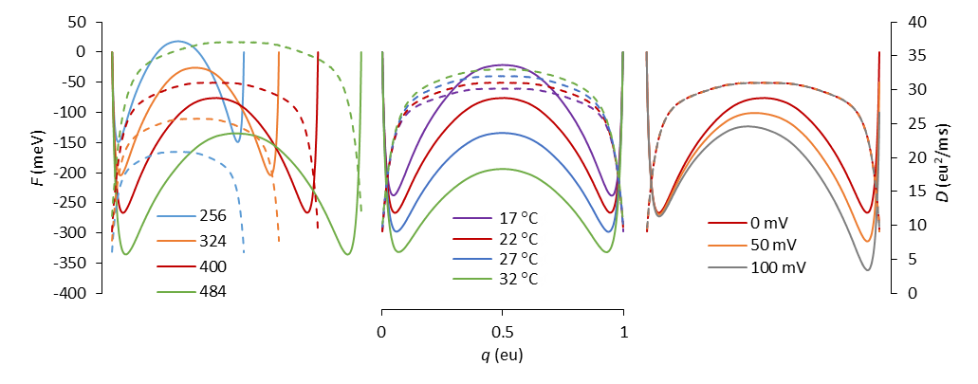
FIG. 9. Free energy (solid lines) and diffusion (dashed lines) landscapes as a function of model parameters (left plot, N; middle plot, T; right plot, V). The red curves correspond to the reference model (N = 400; T = 22 °C; V = 0 mV). Landscapes were calculated from ensemble averaged mesoscopic rate constants, but time averaging of Monte Carlo trajectories yielded nearly identical results.
We wanted to know if the substantial overestimation of macroscopic rate constants after coarse-graining was consistent across all environmental conditions, so we compared the Monte Carlo-derived values for the native process with the averages of Monte Carlo, eigenvalue, and MFPT estimates for the 1D and 2D coarse-grained models at different N, T and V. The results are shown in Fig. 10.
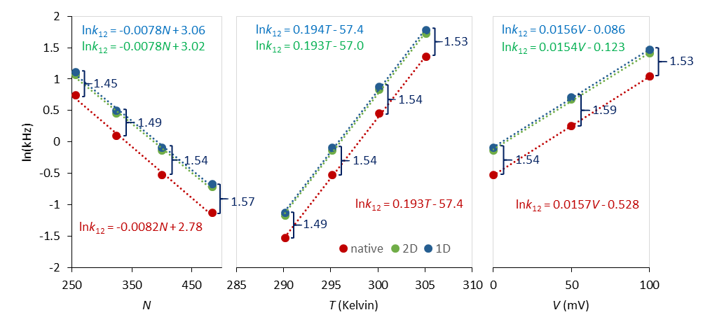
FIG. 10. Linear regression analysis in the semilog plot of forward rate constants with respect to the same environmental conditions as in Fig 9. The native rate constants were calculated as the inverse means of Monte Carlo first passage times from q₁ to q₂, as described in the text. The 1D and 2D rate constants were averaged from their respective Monte Carlo, mfpt, and eigenvalue calculations. Error bars from six experiments are plotted but do not exceed the size of the markers. The linear regression equations are color-matched to their respective data. The ratio of 1D to native rates are shown in blue for each set of conditions.
The results show that under all simulated conditions, the coarse-grained (1D and 2D) estimates of forward rate constants were about 50% greater than the native rate constant, with 1D rates again slightly greater than their 2D counterparts. The approximate 3:2 ratio was fairly consistent across all conditions, though there was a small tendency towards larger ratios with increasing system size (N). Linear fits describing the relationships lnk₁₂ = cX + d, with X representing either N, T, or V, resulted in very similar slopes c for native, 1D, and 2D calculations. These findings suggest that for a range of applied constraints, the overestimation of rate constants caused by coarse-graining could be corrected using a constant factor, which for this model was roughly 1.5. The slightly different 1D- and 2D-derived values of k₁₂ can be attributed to the bend in the 2D reaction pathway (Fig. 2). There is presumably some dynamic information lost when the 2D landscape is projected onto a 1D pmf.
V. DISCUSSION
The inspiration for this study came about when one of us (DS) attempted, as an exercise, to construct a 1D diffusion landscape for the Ising model, and, regardless of method used to calculate the coarse-grained rate constant, failed to reproduce the native rate. Initially thinking the problem lay with the 1D projection onto the order parameter q, we expanded to a 2D representation in q and E, which completely solved the thermodynamic problem, but offered only small improvement in the estimate of the macroscopic rate constant. It became clear that the culprit was the manner in which microscopic rates were averaged at the mesoscopic level. What works for thermodynamics does not necessarily work for kinetics.
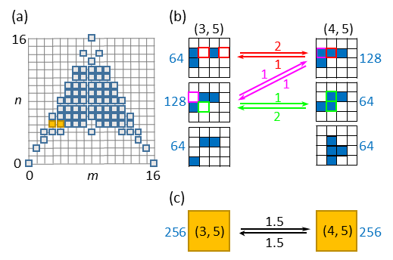
FIG. 11. (a) Mesoscopic grid for the 4 x 4 Ising model. The (3, 5) and (4, 5) states are colored yellow. (b) Microstate sub-groups compatible with the (3, 5) and (4, 5) states. Blue cells are activated. The number of microstates in each sub-group are shown in blue. Arrows show possible transitions between sub-groups. The number (= frequency factor) of color-matched cells which bring about a transition are shown next to the arrows. (c) The mesoscopic transition, where averaged frequency factors = 1.5 are the ⟨r⟩ rates discussed in the Theory section.
The precise origin of the error in coarse-graining is unclear, but a clue to what is happening may be found by analyzing in detail a single transition of a smaller Ising system (Fig. 11), namely the mesoscopic (3, 5) ↔ (4, 5) transition of the 4 x 4 Ising model (N = 16) which leaves energy unchanged. Both mesostates contains 256 microconfigurations, which can be grouped into three sub-configurations. Two out of the three sub-groups experience transitions to the other mesostate. These contribute to the mean rate constant in proportion to the number of ways the transition can occur multiplied by the number of microstates in the sub-group. The average over all microstates is the mesoscopic frequency factor ⟨r⟩. The third sub-groups in each mesostate, comprising a quarter of microconfigurations, do not participate in the reaction at all because there are no transition paths available. These sub-groups do not contribute to the mean rates, and should the system find itself in one of their microstates, a path to a different energy state must be taken. This suggests that for the native process, trajectory pathways are on average a bit longer than predicted by the coarse-grained representation. We conjecture that the additional pathway length is responsible for the slower rates in the native process.
In proteins, there is the concept of frustration, in which trajectories become trapped in blind end states of varying energy depth, leading to low-temperature power-law distributions in reaction rates (Frauenfelder et al., 1991). The simple Ising process does not experience frustration in the same way, since movement in either direction of the order parameter q is always possible, but the inaccessibility of some micro-configurations pathways could be viewed as a minor form of frustration. Perhaps a better description is “diversion”.
One may question whether mesoscopic averaging is an optimal method for coarse-graining the kinetic Ising model. An argument in favor of the method used here is that the microcanonical ensemble, on which the averaging was based, provides a complete thermodynamic description of the system (at least with respect to variables that are functions of q and E). The kinetics at the mesoscopic level are represented by a master equation, but we showed in the 1D projection that the master equation can be represented by a diffusion landscape, and the same should apply to the 2D model. The landscape approach to kinetics is common in protein studies, where sampling of the configuration space using molecular or Langevin dynamics generates a potential of mean force (Harpole and Delemotte, 2017). Fluctuation analysis combined with umbrella sampling can be used to generate a diffusion constant that may be spatially dependent or even have memory for past events (Straub et al., 1987). We attempted to use fluctuation analysis of native dynamics to measure D at the barrier peak using Nyquist’s theorem, but the results continue to overestimate the effective diffusion coefficient (Fig. 5). It is possible that diffusion landscape methods to predict protein kinetics can never be exact, given the level of configurational frustration that has been well documented. In the Ising model, at least, we derive some consolation in the fact that the approximate 3:2 ratio of calculated to “native” rates appears fairly constant across conditions that would be considered physiological, suggesting that for practical purposes, we have “solved” the problem of kinetics under these conditions, provided we multiply calculated rates by the correct factor. It remains to be seen if there is a mathematical solution for the correction factor, or whether it converges to some other value for limiting conditions.

ACKNOWLEDGMENTS

REFERENCES
Belardinelli, R.E., and V.D. Pereyra. 2007. Fast algorithm to calculate density of states. Phys. Rev. E. 75:46701. doi:10.1103/PhysRevE.75.046701.
Best, R.B., and G. Hummer. 2010. Coordinate-dependent diffusion in protein folding. Proc. Natl. Acad. Sci. 107:1088–1093. doi:10.1073/pnas.0910390107.
Frauenfelder, H., S. Sligar, and P. Wolynes. 1991. The energy landscapes and motions of proteins. Science (80-. ). 254:1598–1603. doi:10.1126/science.1749933.
Glauber, R.J. 1963. Time‐Dependent Statistics of the Ising Model. J. Math. Phys. 4:294–307. doi:10.1063/1.1703954.
Harpole, T.J., and L. Delemotte. 2017. Conformational landscapes of membrane proteins delineated by enhanced sampling molecular dynamics simulations. Biochim. Biophys. Acta - Biomembr. 0–1. doi:10.1016/j.bbamem.2017.10.033.
Hummer, G. 2005. Position-dependent diffusion coefficients and free energies from Bayesian analysis of equilibrium and replica molecular dynamics simulations. New J. Phys. 7:34–34. doi:10.1088/1367-2630/7/1/034.
Van Kampen, N.G. 1992. Stochastic Processes in Physics and Chemistry. 2nd ed. North-Holland Personal Library, Amsterdam.
L’Ecuyer, P. 1999a. Tables of linear congruential generators of different sizes and good lattice structure. Math. Comput. 68:249–261. doi:10.1090/S0025-5718-99-00996-5.
L’Ecuyer, P. 1999b. Good Parameters and Implementations for Combined Multiple Recursive Random Number Generators. Oper. Res. 47:159–164. doi:10.1287/opre.47.1.159.
Pleimling, M., and H. Behringer. 2005. Microcanonical analysis of small systems. Phase Transitions. 78:787–797. doi:10.1080/01411590500288999.
Press, W., S. Teukolsky, W. Vetterling, B. Flannery, E. Ziegel, W. Press, B. Flannery, S. Teukolsky, and W. Vetterling. 1992. Numerical Recipes in C. 2nd ed. Cambridge University Press, New York.
Reimann, P., G.J. Schmid, and P. Hänggi. 1999. Universal equivalence of mean first-passage time and Kramers rate. Phys. Rev. E. 60:R1–R4. doi:10.1103/PhysRevE.60.R1.
Saito, M., and M. Matsumoto. 2008. SIMD-Oriented Fast Mersenne Twister: a 128-bit Pseudorandom Number Generator. In Monte Carlo and Quasi-Monte Carlo Methods 2006. Springer-Verlag, Berlin, Heidelberg. 607–622.
Sigg, D. 2014. Modeling ion channels: Past, present, and future. J. Gen. Physiol. 144:7–26. doi:10.1085/jgp.201311130.
Sigg, D., H. Qian, and F. Bezanilla. 1999. Kramers’ Diffusion Theory Applied to Gating Kinetics of Voltage-Dependent Ion Channels. Biophys. J. 76:782–803. doi:10.1016/S0006-3495(99)77243-7.
Sigworth, F.J., and S.M. Sine. 1987. Data transformations for improved display and fitting of single-channel dwell time histograms. Biophys. J. 52:1047–1054. doi:10.1016/S0006-3495(87)83298-8.
Straub, J.E., M. Borkovec, and B.J. Berne. 1987. Calculation of dynamic friction on intramolecular degrees of freedom. J. Phys. Chem. 91:4995–4998. doi:10.1021/j100303a019.
Toda, M., R. Kubo, and N. Saitô. 1992. Statistical Physics I. Equilibrium Statistical Mechanics. 30. 2nd ed. Springer-Verlag, Berlin, Heidelberg.

